Project Development Phase Delivery of Sprint-4

|  |  |
| --- | --- |
| TEAM ID | PNT2022TMID47568 |
| PROJECT NAME | Analytics for Hospitals' Health-Care Data |

**Project Development Phase:**

**Sprint 1:**

* **Data Collection**
* **Data preparation Sprint 2:**
* **Data Exploration Sprint 3:**
* **Dashboard Creation Sprint 4:**
* **Report Creation**
* **Story Creation**

Sprint 4:

Report Creation:

* **Total Admission deposited by Department**
* **Total Availability Rooms by Department**
* **City Code Hospital by Department**
* **Type of Admission by Admission Deposit**
* **Availability Extra Rooms for Illness**
* **Severity of Illness by Departments**

1. **Total Admission deposited by Department**

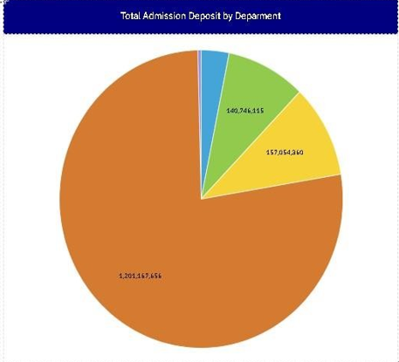

1. **Total Availability Rooms by Department**

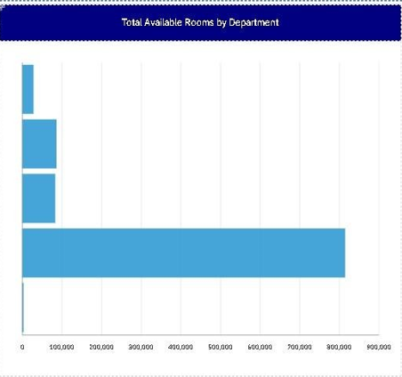

1. **City Code Hospital by Department**

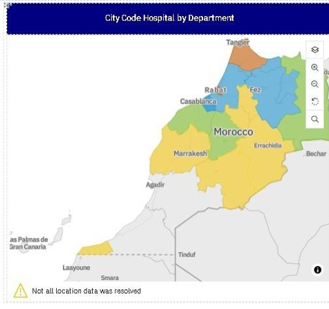

1. **Type of Admission by Admission Deposit**

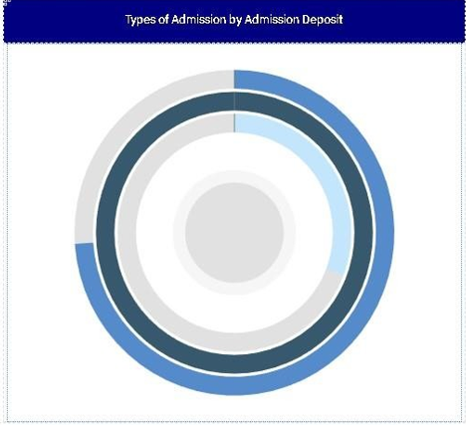

1. **Availability Extra Rooms for Illness**

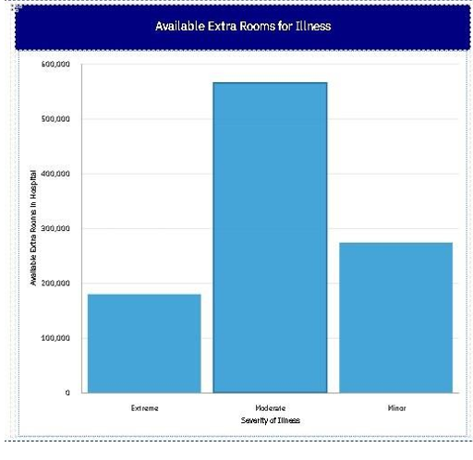

1. **Severity of Illness by Departments**

